Digital Egypt Pioneers Initiative (DEPI)

Day23\_Task1: Social Media Website Template Design Using Bootstrap

**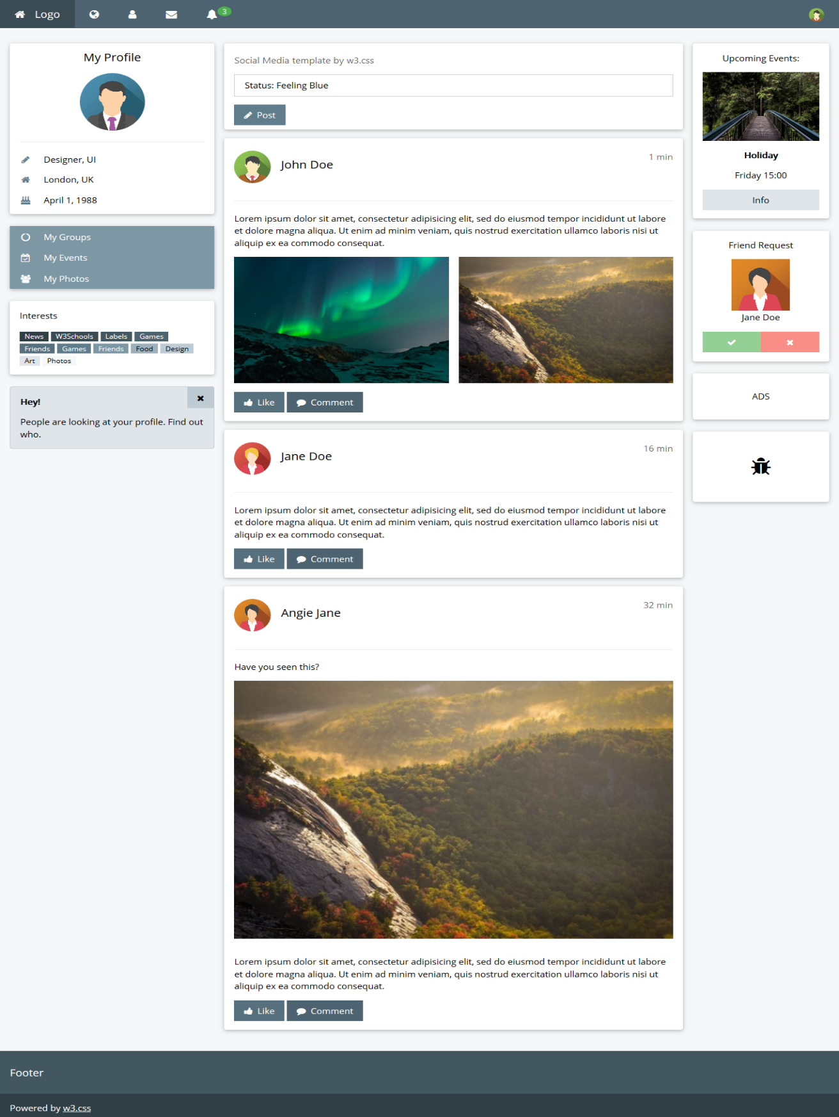**

**Objective:**

Design a social media website layout using **Bootstrap**, ensuring the navbar, columns, and responsive behavior adapt for different screen sizes. Focus on creating a responsive design without using W3.CSS, relying entirely on Bootstrap components and utility classes.

**Steps for Implementation:**

**1. Fixed and Collapsible Navbar:**

* Design a **fixed** navbar using Bootstrap’s .navbar and .navbar-fixed-top classes.
* Make the navbar **collapsible** for smaller screens using Bootstrap’s .navbar-collapse and .navbar-toggler components for the toggle button functionality.

**2. Responsive Column Layout:**

* Implement a three-column layout using Bootstrap’s grid system:
  + On **large screens and above**, set the left column to occupy 3 columns (.col-lg-3), the middle content area to occupy 7 columns (.col-lg-7), and the right column to occupy 2 columns (.col-lg-2).
  + On **medium and smaller screens**, adjust the layout so the left column is 2 columns (.col-md-2), the middle content area is 8 columns (.col-md-8), and the right column remains 2 columns (.col-md-2).

**3. Hide Profile Image on Small Screens:**

* Use Bootstrap’s .d-none utility class to hide the profile image when the screen size is small (.d-sm-none).

**4. Hide Right Column on Extra Small Screens:**

* Hide the right column on extra small screens (below 576px) by applying the .d-none class for extra small screens (.d-xs-none or .d-none.d-sm-block).

**5. Mobile and Tablet View:**

* Ensure the layout adapts seamlessly to **mobile and tablet views** following the design structure in the [social media demo](https://www.w3schools.com/w3css/tryw3css_templates_social.htm" \t "_new), but implemented with **Bootstrap**. Use Bootstrap’s responsive grid and utility classes to handle content flow and layout on these devices.

**Expected Output:**

* **Responsive Social Media Layout**:
  + A fully responsive social media template designed using Bootstrap, with fixed and collapsible navbar, and appropriate layout adjustments for large, medium, and small screens.
* **Responsive Behavior**:
  + On large screens, the layout should be 3-7-2 columns.
  + On medium and smaller screens, the layout should be 2-8-2 columns.
  + Profile image hidden on small screens.
  + Right column hidden on extra small screens.

**Submission:**

Submit your HTML and Bootstrap files along with a brief description of how you implemented the layout, navbar, and responsive behaviors using Bootstrap. Ensure the design matches the template style and follows Bootstrap's grid and utility classes for responsiveness.